Community Preservation Act
20 Years of Investment in Dartmouth

The Community Preservation Act (“CPA) was enacted on September 14, 2000. It enables communities to create a preservation fund through a local property tax surcharge not to exceed 3%. Communities that adopt the CPA are eligible to receive an additional annual contribution from the State. CPA funds can be used for historic preservation, open space preservation [including agriculture preservation and recreation], and affordable housing. Dartmouth adopted the Community Preservation Act in April, 2002 with a 1.5% property tax surcharge.
The Dartmouth Community Preservation Committee (“CPC”) is responsible for recommending CPA funding commitments to Town Meeting for approval. The CPC membership consists of 4 At-Large members and representatives from the Planning Board, Conservation Commission, Parks and Recreation Commission, Housing Authority, and Historical Commission.
Since its adoption, the CPA has brought significant investment and benefits to the Dartmouth community. There is much to celebrate and appreciate from the first twenty years as the projects supported by the CPA represent the work and support of Dartmouth residents and organizations. There are also challenges ahead, the most important of which is to increase investment in affordable housing and historic preservation so that overall CPA investment is more balanced across the three eligible uses.
Investment in Our Community 2002-2022
2023 Average single family residence surcharge $55.96 Average annual State match $240,329
Contributions to the Dartmouth Community Preservation Fund
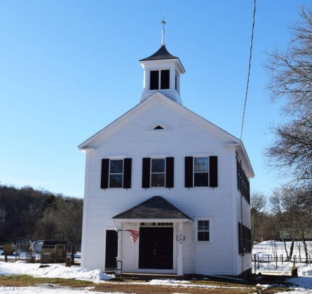
Russells Mills Schoolhouse- Library

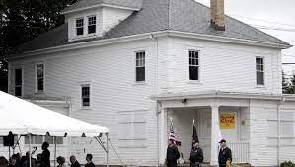
Dartmouth Community Preservation Grants
O’Connor-Sisson Veterans Housing

Total Investment in CPA Funded Projects
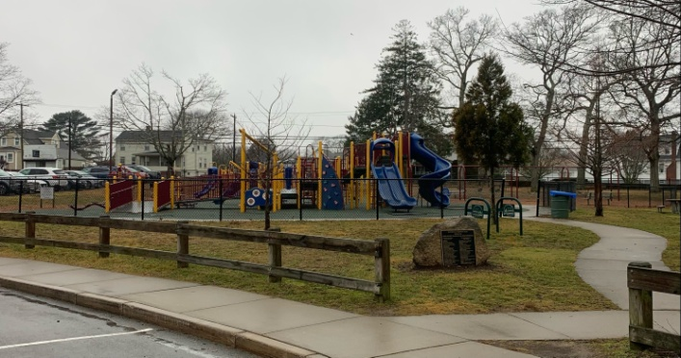
Dartmouth Community Park

Benefits to Our Community 2002-2022
87 project awards 85% of awards completed 91% of committed funds expended
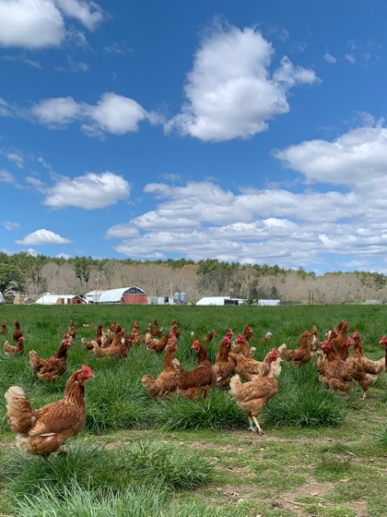
Copicut Farm
Acres of Land Preserved | 724
Acres of Agriculture Preserved | 236
Affordable Housing Units | 11
Historic Buildings/Sites Preserved | 11
Recreation Sites Created | 4
Recreation Sites Improved | 7
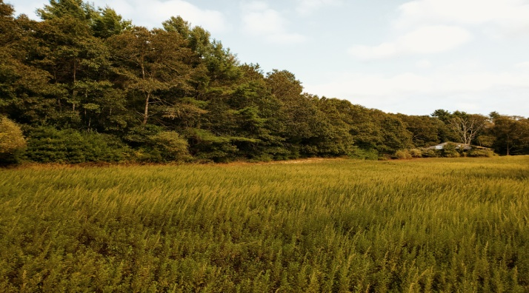
Paradise Farm Conservation Area

