City of Gloucester
Community Preservation Plan

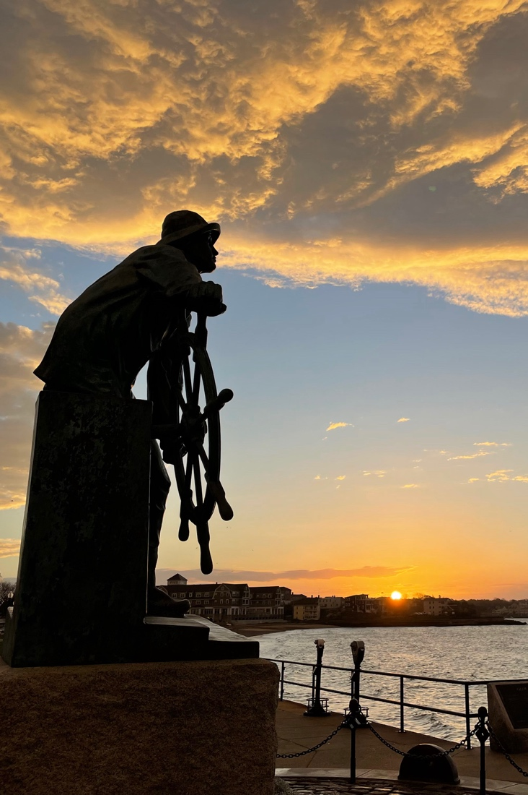
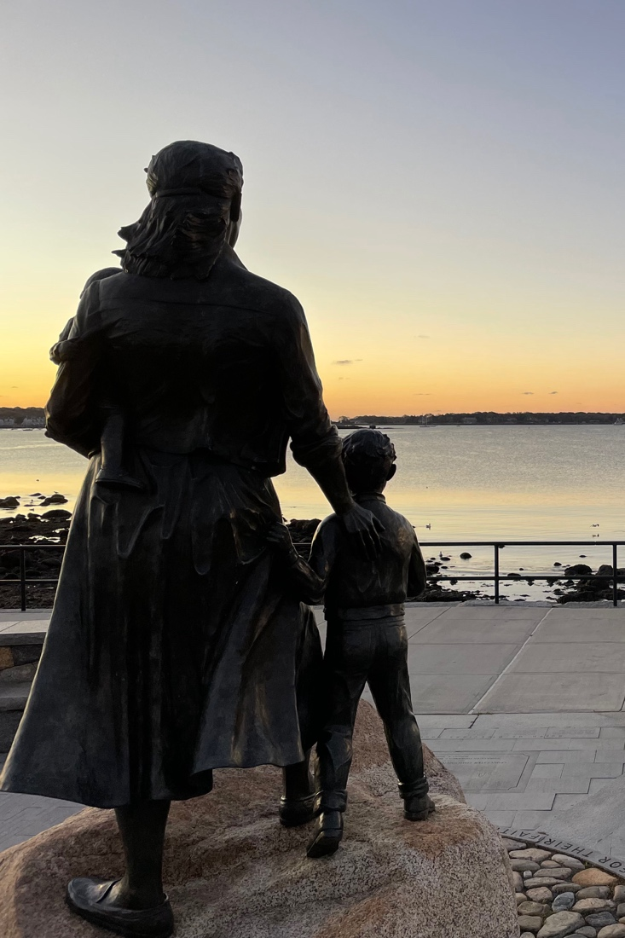
January 2023

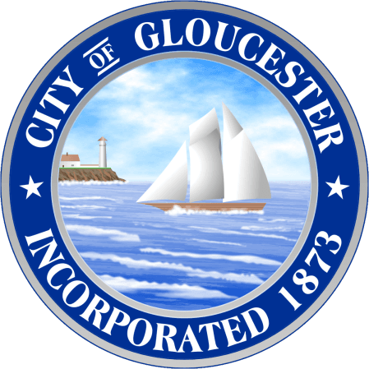

Table of Contents

Introduction 2
CPA Funds Sources and Allowed Uses 4
Open Space & Outdoor Recreation 6
Historic Preservation 10
Community Housing 14
CPA Funding Process 16
Application Guidelines 19
Evaluation Criteria 20

Introduction

About the Community Preservation Act (CPA)
The Community Preservation Act (CPA) is a Massachusetts statute enacted in 2000 that allows participating cities and towns to adopt a real estate tax surcharge of up to 3% in order to create a local Community Preservation Fund for the four community preservation purposes of open space protection, historic preservation, community housing, and outdoor recreation.
In addition to the local tax surcharge, the state of Massachusetts provides matching funds that are not less than 5% and not more than 100% of the funds raised by the community. The actual percentage varies from year-to-year dependent on the health of the Commonwealth’s community preservation trust fund, which is funded by a surcharge on Registry of Deeds transactions.
As of late 2022:
- 194 communities have adopted CPA (55% of the state’s cities and towns)
- Over $3.15 billion has been raised for community preservation funding statewide
- 15,069 CPA projects have been approved by local legislative bodies
- 34,204 acres of open space have been preserved
- Over 3,300 outdoor recreation projects have been initiated
- Over 6,700 appropriations have been made for historic preservation projects
- More than 10,000 affordable housing units have been created with an additional 16,000 units supported

CPA in Gloucester – the Community Preservation Committee (CPC)
Gloucester adopted the CPA in 2008 with a 1% tax surcharge through a city-wide ballot vote. Since then, Gloucester has granted over $8,000,000 to more than 120 projects.
The law requires a municipality adopting the CPA to establish a Community Preservation Committee (CPC) to oversee its Community Preservation Fund. The CPC in Gloucester is made up of nine members including one member each from the Planning Board, the Open Space & Recreation Committee, the Conservation Commission, the Housing Authority and the Historical Commission, along with four At-Large members.

The committee’s primary responsibilities are to regularly maintain Gloucester’s Community Preservation Plan (this document) and to recommend projects for funding to the Mayor and the City Council. The CPC does not initiate projects; rather it collects and reviews proposals submitted by individuals or groups, and then votes whether or not to recommend these proposals to the city.

Funds collected by Gloucester under the CPC since its adoption
Year | Local RE Tax Surcharge | State Match | State Match Percentage | Total CPA Revenue
2010 | $ 436,294 |  |  | $ 436,294
2011 | $ 458,127 | $ 118,680 | 27% | $ 576,807
2012 | $ 473,777 | $ 122,041 | 27% | $ 595,818
2013 | $ 488,445 | $ 127,133 | 27% | $ 615,578
2014 | $ 509,514 | $ 255,091 | 52% | $ 764,605
2015 | $ 558,327 | $ 160,319 | 32% | $ 718,646
2016 | $ 584,612 | $ 165,552 | 30% | $ 750,164
2017 | $ 615,462 | $ 120,295 | 21% | $ 735,757
2018 | $ 646,480 | $ 105,873 | 17% | $ 752,353
2019 | $ 677,742 | $ 122,927 | 19% | $ 800,669
2020 | $ 710,258 | $ 162,106 | 24% | $ 872,364
2021 | $ 734,720 | $ 203,323 | 29% | $ 938,043
2022 | $ 775,640 | $ 322,099 | 44% | $ 1,097,739
2023 |  | $ 298,710 | 39% | $ 298,710
Total | $ 7,669,398 | $ 2,284,149 |  | $ 9,953,547

Gloucester’s Community Preservation Plan (CP Plan)
This CP Plan evolved from previous years’ CP Plans. It incorporates lessons learned from the previous rounds of project selections and funding appropriations. The CPC seeks ongoing input from many interest groups, including city departments and committees, environmental and land trust organizations, and the general citizenry. This CP Plan attempts to capture Gloucester’s community preservation needs and goals in the four CPA target areas. It also outlines the processes by which the Committee solicits, reviews, and recommends project proposals for CPA funding. It is updated regularly to reflect changes in goals or emphasis.

CPA Funds Sources and Allowed Uses

Where Does CPA Funding Come From?
CPA Funds come from two sources. First, Gloucester has adopted a local CPA property tax surcharge of 1%. This modest surcharge results in an annual additional tax of $42.36 on a home with an assessed value of $500,000. Second, the state matches a percentage of these locally raised funds from a CPA Trust Fund funded by the state. The amount of this state match varies each year, depending on how much was brought into the state Trust Fund and how many towns and cities are participating in the CPA.
Additional Funds through Bonding and Leveraging
Communities can also issue bonds against their future CPA revenue stream in order to fund large projects for which adequate CPA funds are not currently available. Gloucester utilized this in 2011 to fund a $2.6 million restoration of City Hall.
Many CPA applicants leverage their CPA grants by acquiring additional funds from other sources. These might include state and federal grant programs, other local funds, non-profit organizations, or private entities.
How CPA Funds Can and Cannot Be Used
The CPA requires that communities spend, or set aside for future spending, a minimum of 10% of annual CPA receipts for each of the following:
- Historic Preservation
- Community Housing
- Open Space and Outdoor Recreation combined
The remaining 70% of funds may be allocated to any one or a combination of the four main uses, on the recommendation of the Community Preservation Committee and subject to the approval of the City Council.
Up to 5% of annual CPA receipts may be spent on the administrative costs of the CPC.
Not Allowed: maintaining existing facilities or supplanting other costs
CPA funds cannot be used for routine maintenance of existing facilities. For example, communities cannot use CPA funds to maintain a municipal park (such as mowing the lawn, emptying trash barrels or dumpsters, etc.) or to maintain a historic town hall (such as cleaning the common areas or paying for utilities.

CPA funds are intended to augment municipal funds, not replace existing funding. To this end, CPA funds may not be appropriated to pay for project costs that have already been appropriated from another source. Any CPA eligible costs for a project that are identified in a municipality's capital improvement program are eligible for funding under the Act, if the municipality has not made a prior funding commitment to pay for such costs.
Usage Category Specific Criteria
Each usage category also carries specific requirements that applications must meet in order to qualify for CPA funds. The table below summarizes these criteria; more detail on these criteria is provided in the following sections of this Plan. For more information visit https://www.communitypreservation.org/allowable-uses.
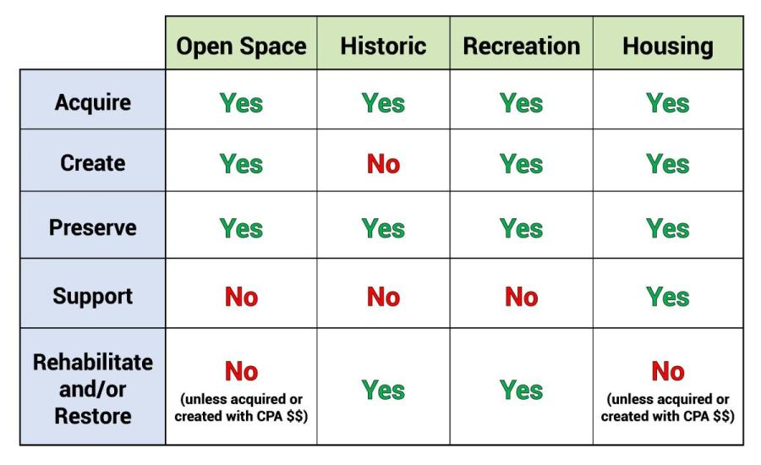

Open Space & Outdoor Recreation

Resources & Needs
Gloucester’s Open Space & Recreation Committee recently published the 2022-2029 Open Space and Recreation plan stating our city’s commitment to protect and improve the open space and recreational resources that contribute to the quality of life in Gloucester. The plan is packed with excellent information on the state of open space and recreation facilities in our city. You can see the complete plan on the city’s website at https://gloucester-ma.gov/1244/Open-Space-and-Recreation-Plan.
Gloucester comprises 26 square miles of widely varying terrain, from open and sandy beaches such as Good Harbor and Wingaersheek, to the rocky, wooded highlands of Dogtown. With over 64 miles of coastal shoreline these natural resources have long been considered our most precious resource, treasured by fishermen, artists, residents, tourists and more.
In building their plan the OSR Committee extensively surveyed Gloucester residents, who identified these top priorities:
- Acquire land for conservation purposes (e.g., wildlife habitat and water supply protection)
- Maintain existing parks and facilities
- Acquire lands for protection of areas from storm surge and sea-level rise
- Improve access to parks and facilities through trails, sidewalks, bike lanes, safer crossings
- Acquire land for parks and facilities in areas that lack parkland

Residents noted that areas that could use improvement include boating facilities, gardening programs, improved bike paths and pickleball courts, among other suggestions.
The Open Space & Recreation Committee published a Seven-Year Action Plan Map that gives potential applicants a nice view of the committee’s priorities. We’ve produced it here for your reference. The full Seven-Year Action Plan Matrix can be found in Section 9 of the OSRC plan.

Open Space & Recreation Plan - Seven-Year Action Plan Map
This map identifies the locations listed in the OCRC’s survey of Gloucester residents as areas to be addressed.
Goals & Possibilities
The 2022 Open Space and Recreation Plan states five primary goals.
- Develop and direct a program of strategic preservation of Open Space and Recreation Lands using the inventory produced for this plan.
- Improve management and stewardship of Gloucester’s Open Space including conservation lands, trails, forests, and vista points.
- Maintain, enhance, and expand Gloucester’s Recreation Lands including parks, playgrounds, athletic facilities, beaches, and public landings.
- Protect and Improve Gateways to and Create Strategic Connections between Open Space and Recreation Areas.
- Plan for and incorporate the concerns of Climate Change and Resiliency in all policies and operations programs related to Open Space and Recreation Areas.
In addition, the Plan prioritizes three areas for permanent protection via conservation restrictions:
- Dogtown parcel cluster and North Gloucester Woods
- City beaches and adjacent marsh lands
- City parks and active recreation areas
The CPC gives priority to projects that are consistent with these goals but will consider any Open Space and Outdoor recreation project applications that are eligible under Massachusetts law.
Achieving progress towards any of these goals takes planning and resources. The CPC can help with capital resources, and by connecting interested applicants with other potential funding sources as well as with like-minded residents with experience.

Category Specific Eligibility – Open Space
CPA funds may be spent on the acquisition, creation, and preservation of open space, and for the rehabilitation or restoration of any open space that has been acquired or created using CPA funds. It is important to note that a permanent deed restriction that protects the property for conservation in perpetuity is required for all real property interests acquired under CPA. This includes, but is not limited to, the following:
- Land to protect existing and future well fields
- Aquifers, recharge areas, and watershed land
- Agricultural land
- Grasslands, fields and forest land
- Fresh and saltwater marshes and other wetlands
- Ocean, river, stream, lake and pond frontage
- Beaches, dunes, and other coastal lands
- Lands to protect scenic vistas
- Land for wildlife or nature preserve
- Land for recreational use (see separate category information, below)

Category Specific Eligibility – Outdoor Recreation
CPA funds may be used for the acquisition of land to be used for recreation, or for the creation of new recreational facilities on land a community already owns. A 2012 amendment to CPA broadened the law to also allow for the rehabilitation of existing, outdoor recreational facilities. The amendment made it clear that with respect to land for recreational use, "rehabilitation" could include the replacement of playground equipment and other capital improvements to the land or the facilities thereon to make them more functional for their intended recreational use. Eligible projects might include (but not be limited to) the use of land for:
- Community gardens
- Trails
- Noncommercial youth and adult sports
- Parks, playgrounds or athletic fields
The Community Preservation Coalition has an excellent page with more information on eligibility at https://www.communitypreservation.org/allowable-uses.

Historic Preservation

Resources & Needs
Gloucester’s historic resources are places, artifacts, memorials, structures, or vessels that provide meaningful connections to the past. In some cases, these links to the past have been preserved or protected through the efforts of government and institutions. There are 34 Gloucester listings on the National Register of Historic places, including two that have been deemed National Historic Landmarks (the Schooner Adventure and the Beauport Sleeper-McCann House); in other instances, valuable historic resources remain unprotected. Gloucester is rich with History and the desire to preserve it.
The harbor area has long been the center of Gloucester; its historic role is preserved in the creation of the Gloucester Historic District. Buildings, museums, and special structures celebrate our Maritime history. Local and National Historic District designations encompass much of Middle Street and the west end of Main Street. Middle Street includes several 18th century Georgian-style houses, while Main Street boasts Federal-style seaport buildings including the Blackburn Tavern. Two museums are within the district – the 1782 Sargent Murray Gilman Hough House built for Judith Sargent Murray, an early advocate for women’s equality, and the Cape Ann Museum which includes the 1804 house built by Captain Elias Davis, a successful Gloucester Sea Captain.
Also within the Historic District are Gloucester’s City Hall, dedicated in 1871, and listed in the National Register of Historic Places and the Gloucester Lyceum and Sawyer Free Library, which includes the 1764 Saunders House. Both historic treasures are defining features of downtown and cherished by Gloucester residents. Historic houses are also located across the city including several first period houses, those built before 1725, and listed in the National Register of Historic Places.
Additionally, two unique homes are preserved and are significant visitor destinations – the Hammond Castle, the medieval style castle home of famed inventor John Hays Hammond Jr. and Beauport, the eclectic summer home of the collector and interior designer Henry Davis Sleeper. Both are on the National Historic Registry and Beauport is also a registered Historic Landmark.
Also listed on the Historic Registry is the 1848 granite home and studio of Gloucester’s renowned artist Fitz Henry Lane. This treasure is located on the Harbor Loop with a commanding view of Gloucester Harbor. The house is now owned and maintained by the city.
Located across Gloucester Harbor from downtown is The Rocky Neck Art Colony, one of two Cultural Districts in Gloucester. The other is the Harbortown District located in downtown. Gloucester is the only city in Massachusetts to have two designated Cultural Districts. Rocky Neck is known as America’s oldest working art colony and has since the early 19th century attracted painters and sculptors including such luminaries as Winslow Homer, Augustus Buhler, Frank Duveneck, Marsden Hartley, Edward Hopper.
The city’s maritime heritage is embodied in the Schooner Adventure, a preserved 121-foot schooner built in 1926 that is a National Historic Landmark. The Adventure is now used as an experiential classroom. Maritime Gloucester on Harbor Loop features the country’s oldest continuously operating marine industrial railway and a 19th century mill building. The Museum houses exhibits on the city’s maritime industrial history as well as a new Maritime Science Center which includes a year-round indoor touch tank and two to three dedicated teaching spaces. The proximity of these historic resources highlights the relationship between the city’s maritime history and its artistic heritage.
The villages of Magnolia and Annisquam have active historical societies and small museums memorializing their traditions and history.
Several city entities are charged with the preservation and stewardship of historic resources. The Historical Commission serves a broad role in promoting preservation activities using the 1990 Historic Preservation Plan for guidance. The Historic District Commission maintains stewardship in the Historic District. The Archives Committee collects and organizes historic records. The Sawyer Free Library also maintains historic records, books and paintings. The City Hall Restoration Committee is working to restore City Hall and volunteers at the Gloucester Lyceum and Sawyer Free Library are doing the same, particularly focusing on the imperiled Saunders House. The Cape Ann Museum is steward to both the Captain Elias Davis House and the White Ellery House as well as to important city archives.

Goals & Possibilities
Some Identified Needs
It is fair to say that some of Gloucester’s greatest attributes also present some of its greatest challenges. The future of Gloucester’s historic resources is dependent on the stewardship that its citizens can offer. Despite valiant efforts, however, many historic structures are decaying or threatened with demolition. Some of Gloucester’s earliest homes are significantly degraded, early burial grounds and cemeteries are in disrepair and the city’s valuable records and archives need additional secure storage space. The existence of the Community Preservation Act provides an opportunity to address some of these pressing needs.
Some Possibilities for Gloucester
There are many ongoing efforts to preserve and restore some of Gloucester’s most cherished historic resources including City Hall and the Saunders House at the Sawyer Free Library. Another important project is the preservation of the city’s archives which house some nationally significant documents. There are efforts to restore and preserve the city’s oldest burial grounds as well as projects by nonprofit organizations such as the Schooner Adventure and the restoration of the iconic Paint Factory at the entrance to Gloucester harbor.
Examples of historic resource projects that may be carried out under the CPA:
Acquisition
- Acquire a historic site or landscape
- Provide a match for federal or state grants such as the Massachusetts Preservation Projects Fund
Preservation
- Purchase a preservation easement to protect façade or other historical features
- Restore historic buildings to reverse inappropriate alterations
- Establish or expand signage or markers at historic sites
- Conduct historical or archeological surveys necessary for a preservation project or creation of a new historic district
- Restore archival documents
- Provide grants to acquire or preserve an historic property in private nonprofit ownership provided that city acquires a preservation restriction to protect the public's investment
Rehabilitation and Restoration
- Rehabilitation and restoration of artwork, statues, public art, etc.
- Restore or upgrade municipal historic resources such as town halls, libraries, town commons, parks, or cemeteries
- Adaptively reuse historic sites such as the upgrade and rehabilitation of fire houses, churches, mills, police stations, town halls, or schools for community housing or another municipal use
- Capital improvements to historic resources that are necessary to comply with state building codes
- Provide new utilities and other site work necessary for a preservation project
- Mitigate environmental contamination at historic sites
- Provide Americans with Disabilities Act (ADA) and Massachusetts Architectural Access Board (MAAB) compliant accessibility at historic sites, such as elevators, ramps and restrooms.
- Restore and preserve historic landscape

Category Specific Eligibility
The Act requires that a participating community "…shall spend or set aside for later spending…not less than 10% of the annual revenues for historic resources."
An historic resource is defined as a building, structure, vessel, or other real property, document or artifact that is:
- Listed on the State Register of Historic Places, or
- Determined by the local Historical Commission to be significant to the history, archeology, architecture, or culture of the city. The applicant must provide proof of either of these statuses during the application process

CPA funds may be spent on the acquisition, preservation, rehabilitation and restoration of historic resources. Communities using CPA funds on historic resources must adhere to the United States Secretary of the Interior's Standards for the Treatment of Historic Properties.
The Community Preservation Coalition has an excellent page with more information on eligibility at https://www.communitypreservation.org/allowable-uses.

Community Housing

Resources & Needs
The City of Gloucester has a fundamental obligation to ensure that people who now live and work here can continue to afford to live here. The current inadequate housing supply and escalating home prices are causing displacement, individual and family stress, pressure on existing businesses, and deterrence to the development of new business. Furthermore, the salaries of people who provide services to the local community - teachers, city workers, health care providers, and others - are not sufficient to meet the current cost of housing.
The CPA statute defines “Community Housing” as housing for low- and moderate-income individuals and families, including senior housing. "Low-income housing" is for households whose annual income is less than 80% of the area-wide median income. "Moderate income housing” is for households whose annual income is less than 100% of the area-wide median income. The area-wide median income is determined annually by the United States Department of Housing and Urban Development (HUD).
Gloucester's estimated area-wide median income in 2022 is $140,200 for a family of four. Low-income housing must serve those households whose annual income is less than 80% of the area-wide median income. In 2022, this is about $112,160 for a family of four by the Massachusetts Department of Housing and Communities Development. CPA funds can also be used for housing units serving households of 80% - 100% of the Area Median Income.

Goals & Possibilities
In July 2017, The Massachusetts Department of Housing and Communities Development approved the City of Gloucester's Housing Production Plan. That Plan established 10 Goals and Strategies for Affordable Housing Production:
- Create opportunities to develop a diverse and affordable housing stock to meet the needs of a changing demographic profile in the city.
- Encourage affordable housing development to achieve and maintain the goal of having at least 10% of Gloucester’s housing as affordable. This goal is laid out in Massachusetts state planning law Chapter 40B. More information on this law is at https://www.mass.gov/chapter-40-b-planning-and-information.
- Develop strategies to ensure that existing affordable housing units are preserved for long-term affordability.
- Identify sites that are most appropriate to accommodate Gloucester’s needed growth in housing.
- Review and revise the Zoning Ordinance to remove barriers and create more incentives toward the production of affordable housing in appropriate locations.
- Leverage existing funding sources to meet existing and future housing needs.
- Minimize the displacement of lower-income households.
- Promote safe, healthy housing and living.
- Ensure that the city is affirmatively furthering fair housing obligations.
- Ensure that staffing and commissions have capacity to implement HPP.
During the upcoming year, the Community Preservation Committee plans to coordinate with the Gloucester Affordable Housing Trust to understand their vision and strategies for Affordable Housing in Gloucester. Working together with the Affordable Housing Trust, our CPC Committee can better understand the Community Housing needs and funding resources available for affordable housing within Gloucester.

Category Specific Eligibility
CPA funds may be spent on the acquisition, creation, preservation and support of community housing and for rehabilitation or restoration of Community Housing that has been acquired or created using CPA funds. Support of Community Housing shall include, but not be limited to, programs that provide grants, loans, rental assistance, security deposits, interest-rate write downs or other forms of assistance directly to individuals and families who are eligible for Community Housing, or to an entity that owns, operates or manages such housing, for the purpose of making housing affordable.
The CPA requires that whenever possible, preference be given to the adaptive reuse of existing buildings or construction of new buildings on previously developed sites.

CPA Funding Process

The CPA Funding process is straightforward. If you have any questions along the way, you can reach the CPC by contacting the city of Gloucester’s Grants Manager in the Community Development department by calling (978) 325-5230 or through our page at https://gloucester-ma.gov/103/Community-Preservation-Committee.
Here is the 2023 calendar for CPA Project applications.
2023 Application Cycle opens | Tuesday February 21
Project Eligibility Forms due | Tuesday March 7
Completed Full Application due | Tuesday May 2
Applicant Presentations | June – July
CPC Deliberations | August – September
CPC Recommendations to the Mayor | Late September
City Council Approval | Late January 2024
Funds available to Grantees | March 2024

2023 Application Cycle opens. At the CPC’s February meeting this plan is presented for public input and questions from potential applicants. Potential applicants need to register with Neighborly, a web-based grant management system that we use for managing all application submissions. To do so click on the Register link at https://portal.neighborlysoftware.com/gloucesterma/.
Project Eligibility Forms due. Applications for CPA Funds must meet a set of criteria defined in the CPA statute. An excellent overview of these criteria is at https://www.communitypreservation.org/allowable-uses. If you have any questions, contact the CPC. If you believe you have a project eligible for CPA funds, then fill out the Eligibility form at Neighborly once you’ve registered.
The Eligibility form is short and to the point. It’s designed so that you don’t have to go through the much lengthier full application if your project doesn’t meet the state’s criteria for CPA funds.
The CPC will review your Eligibility form and contact you if we have any questions before the committee votes to decide whether your project is eligible at our March meeting. You will be notified immediately of our eligibility decision.
Completed Full Applications due. From March to May we ask applicants to submit all of their information to support their application. The Neighborly online portal has areas to submit all of the information we need. You will describe your project comprehensively and in detail, including but not limited to:
- Your organization’s mission
- Detailed project description
- Which CPA category your project falls in and what community needs it serves
- Project schedule including all major milestones
- Expense breakdown, including which items you expect to fund with CPA funds
- All non-CPA funding sources and amounts expected from each

Applicant Presentations. In late spring and early summer, the CPC assigns one of our members as a liaison to each grant applicant. We help you answer any questions about the process in an effort to make your application as complete as possible. During this time, we frequently schedule a site visit where you can show CPC members what your project will entail.
In late summer we ask each applicant to attend one of our CPC meetings to present their application and engage in a question & answer session with committee members. Presentations are typically held to 5-7 minutes, with 15 minutes for Q&A.
CPC Deliberations. Once all applications are complete and presentations have been made the CPC works to determine which applications it will recommend for funding to the Mayor and the City Council. Our first step is to confirm the amount of CPA funds we have available with the City Auditor. After that the CPC holds one or more public meetings to discuss the merits of each application individually and as a whole with respect to our available funds.
CPC Recommendations to the Mayor. In September we complete these deliberations and vote to recommend a slate of projects to the mayor for funding. The mayor then refers that slate to the City Council, who must approve all budgetary allocations.
City Council Approval. The City Council usually immediately refers these recommendations to its Budget and Finance committee, which schedules the CPC and applicant representatives to summarize the recommendation and answer their questions at one of their public meetings. At this time the B&F committee will vote whether to approve each project, after which their recommendations are referred back to the full City Council.
The full Council then schedules the slate of projects for final review and approval. In most cases this takes place in late January or early February.
Funds available to Grantees. Once the City Council approves a project the city’s Community Development Grants Department will draft a legal agreement between the city and the applicant that specifies the amount of the grant and the procedures for the applicant to acquire funds. In short, the applicant contracts to have work done, receives invoices for that work, and submits those invoices to the city for payment. The city sends payment directly to the entity that issued the invoice.
It's important for the applicant to follow the letter of the agreement, and specifically to take care not to submit invoices for work that was not approved under the scope of the agreement. If they do, the invoice may not be paid.
One element of the agreement requires applicants to submit a quarterly report informing the city and the CPC of your project’s progress.
Helpful links for Potential CPA Project Applicants
CPA Overview: https://www.communitypreservation.org/about
Is Our Project Allowable? https://www.communitypreservation.org/allowable-uses
CPA Success Stories: https://www.communitypreservation.org/advanced-search?keywords=cpa%20success
Many more helpful articles are available by visiting Community Preservation Coalition website at https://www.communitypreservation.org/

Application Guidelines

Our application uses a two-step process. The first step asks potential applicants to submit a brief project description to allow the CPC to determine if the project is eligible for CPA funding. This avoids applicants having to prepare a detailed submission for a project that can’t be funded. The applicant submits a full application only after a project is determined to be eligible.
Once a project is deemed to be eligible applicants can begin the full application process. The full application asks applicants for a comprehensive project description, including but not limited to:
- Contact information for the project representative including name, phone number and email address
- Amount of CPA funding requested
- Total project cost
- Detailed project budget and projected schedule
- Other non-CPA sources of funding
- Project description and identification of which CPA category it falls into
- A description of project goals
- The community need the project addresses
- Community support, stated in the form of testimonials, letters of support, etc.

This project funding, detailed budget and schedule components are particularly important. In making its decisions the CPC assesses how the applicant is implementing cost-saving measures and leveraging other funding or in-kind donations. Therefore, it is important for the CPC to examine project budgets in some detail, including proposed funding from other public sources, private donations, and in-kind donations of materials or professional services.
As described earlier in this plan Gloucester uses Neighborly, a web-based grant management system for managing all application submissions. To Register and begin the application process go to https://portal.neighborlysoftware.com/GLOUCESTERMA/.

Evaluation Criteria

General Criteria
The Gloucester CPC can only consider proposals that are eligible for Community Preservation Act (CPA) funding according to the requirements described in the CPA legislation, specifically:
- The acquisition, creation, and preservation of open space. Rehabilitation and restoration will be considered if acquired or created with CPC funding.
- The acquisition, preservation, rehabilitation, and restoration of historic resources.
- The acquisition, creation, preservation and rehabilitation/restoration of land for recreational use.
- The acquisition, creation, preservation and support of community housing. Rehabilitation and restoration will be considered if project was created/purchased with CPC money
- The acquisition of land to be used for passive or active recreation, or for the creation of new recreational facilities on land a community already owns.
Preference will be given to proposals that address as many of the following general criteria as possible:
- Consistent with current planning documents that have received wide scrutiny and input and have been adopted by the city.
- Preserve the essential character of the city.
- Save resources that would otherwise be threatened and/or serve a currently under-served population.
- Demonstrate practicality and feasibility, and demonstrate that the project can be implemented expeditiously and within budget.
- Produce an advantageous cost/benefit value.
- Leverage additional public and/or private funds.
- Preserve or utilize currently owned city assets.
- Receive endorsement by municipal boards or departments.

Category Specific Criteria
Open Space proposals that address as many of the following specific criteria as possible will receive preference:
- Permanently protect important wildlife habitats, including areas that
  - are of local significance for biodiversity;
  - contain a variety of diverse geological and vegetational habitats;
  - contain a habitat type that is in danger of vanishing from Gloucester; or
  - preserve habitat for endangered species of plants or animals.
- Provide opportunities for passive recreation and environmental education.
- Preserve and/or restore threatened or deteriorating public lands.
- Protect or enhance wildlife corridors, promote connectivity of habitat or prevent fragmentation of habitats.
- Provide connections with existing trails or potential trail linkages.
- Preserve scenic views and/or border a scenic road.
- Provide flood control/storage.
- Preserve important surface water bodies, including wetlands, vernal pools or riparian zones.
- Preserve a primary or secondary priority parcel in the Open Space Plan.

Outdoor Recreation proposals that address as many of the following criteria as possible will receive preference:
- Support multiple active and passive recreation uses.
- Serve a significant number of residents.
- Expand the range of recreational opportunities available to Gloucester residents of all ages.
- Demonstrate a public benefit and be open to the public.
- Jointly benefit Conservation Commission and Open Space & Recreation Commission initiatives by promoting a variety of recreational activities.
- Maximize the utility of land already owned by Gloucester.

Historical Resource proposals that address as many of the following criteria as possible will receive preference:
- Protect, preserve, enhance, restore and/or rehabilitate:
  - historic, cultural, architectural or archaeological resources of significance
  - city-owned properties, features or resources of historical significance
  - the historical function of a property or site
- Support the adaptive reuse of historic properties.
- Demonstrate a public benefit and be open to the public.
- Demonstrate the ability to provide permanent protection for maintaining the historic resource.
- Reside within a Gloucester Historic District, on a State or National Historic Register, or eligible for placement on such registers, or on the Gloucester Historical Commission’s Cultural Resource Inventory.

Affordable/Community Housing proposals that address as many of the following criteria as possible will receive preference:
- Contribute to the state Affordable Housing Law (Chapter 40B) goal of maintaining at least 10% affordable housing.
- Promote a socioeconomic environment that encourages diversity.
- Provide housing that is harmonious in design, scale, setting and materials with the surrounding community.
- Intermingle affordable and market rate housing at levels that exceed state requirements for percentage of affordable units.
- Ensure long-term affordability.
- Promote use of existing buildings or construction on previously developed or city-owned sites.
- Convert market rate to affordable units.
- Give priority to local residents, city employees, and employees of local businesses.

