Grantor: Westport Land Conservation Trust, Inc.
Grantee: Town of Westport, Conservation Commission
Property address: Adamsville Road, Westport, MA 02790
Title Reference: Bristol County S.D. Registry of Deeds Book 12369, Page 1.

CONSERVATION RESTRICTION

From

Westport Land Conservation Trust, Inc.

To

The Town of Westport, Conservation Commission

St. Vincent De Paul Property – Phase II
Adamsville Road, Westport

The WESTPORT LAND CONSERVATION TRUST, INC., a Massachusetts non-profit corporation with an address of P.O. Box 3975, Westport, MA 02790, its successors and assigns (“Grantor”), acting pursuant to Sections 31, 32 and 33 of Chapter 184 of the Massachusetts General Laws, for consideration paid of Four Hundred and Forty-Five Thousand Dollars ($445,000.00), the receipt and sufficiency of which is hereby acknowledged, GRANTS with quitclaim covenants to the TOWN OF WESTPORT, a municipal corporation in Bristol County, Massachusetts, acting by and through its Conservation Commission by authority of M.G.L. Chapter 40, Section 8C, with offices at 856 Main Road, Westport, Massachusetts, 02790, its successors and permitted assigns ("Grantee"), in perpetuity and exclusively for conservation purposes, the following described Conservation Restriction (hereinafter, the “Conservation Restriction” or the “Restriction”) on a parcel of land of approximately 21.13 acres located in the Town of Westport, Massachusetts (the “Premises”), said parcel being shown as “Conservation Area A” on a plan of land entitled “Conservation Restriction Plan of Land in Westport, MA & Little Compton, RI, Prepared for Westport Land Conservation Trust, Inc.” dated February 7, 2018. Said Plan is recorded with the Bristol County Southern District Registry of Deeds in Plan Book 177, Page 48 (hereinafter referred to as “the Plan”), and a reduced copy of the Plan is attached hereto as Exhibit A.

I. PURPOSES.

This Conservation Restriction is defined in and authorized by Sections 31-33 of Chapter 184 of the Massachusetts General Laws and otherwise by law. The purpose of this Conservation Restriction is to assure that the Premises will be maintained in perpetuity for conservation purposes, in a natural, scenic, and undeveloped condition, and to prevent any use or change that would materially impair or interfere with the conservation or preservation values “conservation values” listed below.

The Premises was acquired, in part, using M.G.L. c. 44B Community Preservation Act funds. A copy of the Town Meeting Vote appropriating the funds is attached hereto as Exhibit B.

The conservation values include the following:

- Habitat & Biodiversity Protection. Conservation of the Premises will protect a diverse array of habitats used by a variety of wildlife including wooded swamp, upland forest, and open fields, including Priority Habitat of Rare Species as identified by the Massachusetts Natural Heritage and Endangered Species Program (EH 232). Conservation of the Premises will contribute to the protection of this habitat.

- Water Quality Protection. The Premises include wooded wetlands, the conservation of which will contribute to the protection of water quality by restricting certain activities that commonly degrade water quality and by prohibiting permitted dwellings and thereby eliminating septic systems, runoff, and water consumption commonly associated with such dwellings.

- Recreation. Protection of the Premises will create recreational opportunities for the public through the provision of public access to a network of trails and the development of a community park to be established on the Premises.

- Scenic Views. The Premises contain approximately 1,000 feet of frontage on Adamsville Road, a well-traveled local roadway. Preservation of the Premises will help ensure the continued scenic and natural beauty of the area.

- Prime Forest Soils. A portion of the Premises is mapped by the Department of Natural Resources Conservation at the University of Massachusetts at Amherst as having Prime Forest Land or forestland of Statewide or Local Importance. Preservation of the Premises will ensure the protection of this land for future timber production.

These conservation values of the Premises and public benefits of this Conservation Restriction are described in more detail in a Baseline Documentation Report to be kept on file at the office of Grantee and incorporated herein by this reference. Grantor and Grantee acknowledge that this Report provides an accurate representation of the condition and the values of the Premises at the time of the granting of this Conservation Restriction and is intended to serve as an objective information baseline for subsequent monitoring of compliance with the terms of this Conservation Restriction as described herein.

II. PROHIBITED ACTS AND USES, EXCEPTIONS THERETO AND PERMITTED USES

- Prohibited Acts and Uses.

Subject to the exceptions set forth herein, the Grantor will not perform or allow others to perform the following acts and uses which are prohibited on, above, and below the Premises:

- Constructing, placing or allowing to remain any temporary or permanent building, tennis court, landing strip, mobile home, swimming pool, asphalt or concrete pavement, parking lot, sign, fence, billboard or other advertising display, antenna, utility pole, tower, solar panel, solar array, conduit, line or other temporary or permanent structure or facility on, above or under the Premises;

- Mining, excavating, dredging or removing from the Premises of soil, loam, peat, gravel, sand, rock or other mineral resource or natural deposit or otherwise making topographical changes to the area;

- Placing, filling, storing or dumping on the Premises of soil, refuse, trash, vehicle bodies or parts, rubbish, debris, brush, leaves, grass or tree cuttings, other vegetation generated off-site, junk, waste or other substance or material whatsoever or the installation of underground storage tanks;

- Cutting, removing or otherwise destroying trees, grasses or other vegetation;

- Activities detrimental to drainage, flood control, water conservation, water quality, erosion control, soil conservation, or archaeological conservation;

- Use, parking or storage of vehicles including boats, trailers, motorcycles, motorized trail bikes, snowmobiles, mopeds, all-terrain vehicles, and all other motor vehicles on the Premises, except for vehicles necessary for public safety (i.e. police, fire, ambulance or other governmental officials) in carrying out their official duties, and except for the use of motorized wheelchairs or similar assistive devices for the mobility impaired;

- Subdivision or conveyance of a part or portion of the Premises alone, or division or subdivision of the Premises (as compared to conveyance of the Premises in its entirety which shall be permitted), and no portion of the Premises may be used towards building or development requirements on this or any other parcel;

- The disruption, removal, or destruction of the stone walls or granite fence posts on the Premises;

- The use of the Premises for more than de minimis commercial recreation, business, residential or industrial purposes;

- Any other use of the Premises or activity which is inconsistent with the purpose of this Conservation Restriction or which would materially impair its conservation values.

- Reserved Rights.

The Grantor reserves the right to conduct or permit the following activities and uses on the Premises, but only if such uses and activities do not materially impair the conservation values or purposes of this Conservation Restriction:

- Permits. The exercise of any right reserved by Grantor under this Paragraph B shall be in compliance with zoning, the Wetlands Protection Act, and all other applicable federal, state and local laws, rules, regulations, and permits. The inclusion of any reserved right requiring a permit from a public agency does not imply that the Grantee or the Commonwealth takes any position whether such permit should be issued.

- Community Park Uses. The construction, installation, maintenance, renewal and use of a community park, provided that (a) motorized uses shall not be permitted, except as described in B(4), below, and (b) the uses do not interfere with the conservation values described above, including without limitation the preservation of rare species habitat. For the purposes of this paragraph, allowable elements associated with a “community park” shall include meadows, recreational fields, trails, playground structures, community gardens, farmers’ market, and other improvements commonly associated with community parks, but shall not include buildings or other significant structures, without prior approval of the grantee.

- Historic House Envelope. Within the “Historic House Envelope” as shown in Exhibit C, (a) the renovation, repair, use, maintenance, and if necessary removal of the existing structures as shown in the Baseline Document Report for residential or commercial purposes, including as offices for the Grantor or tenants of Grantor, (b) with prior permission of Grantee, the construction, repair, use, and maintenance of other structures necessary for the Grantor’s use as offices, educational uses, and/or uses associated with the Community Park, and (c) the construction, repair, use, and maintenance of infrastructure ancillary to the above uses, such as utilities, septic systems, wells, access drives, and parking, provided that such infrastructure and uses do not materially interfere with the operation and function of the community park permitted above.

- Gymnasium Envelope. Within the “Gymnasium Envelope” as shown in Exhibit C and with prior permission of Grantee, the renovation, repair, use, maintenance and if necessary removal of the existing structures as shown in the Baseline Document Report for any purpose or use customarily used in a gymnasium or which complements the community park and/or supports the Grantor’s ability to manage and maintain the community park, including infrastructure ancillary to such uses such as utilities, septic systems, wells, access drives, and parking, provided that such uses do not materially interfere with the operation and function of the community park permitted above.

- Structures and Infrastructure Related to Community Park Uses. The construction, installation, maintenance, use and replacement of infrastructure associated with buildings and uses within the Gymnasium and Historic House Envelopes, as permitted in Paragraphs B(3) and B(4), above, and the construction, installation, maintenance, use and replacement of infrastructure associated with and reasonably necessary for the community park uses permitted in Paragraph B(2), above, including parking lots, access roads, fences and gates, bathrooms and associated septic systems, utilities, irrigation, wells, and other infrastructure customarily accessory and incidental to the use, maintenance, and operation of a community park. Any such structures shall not interfere with the conservation values described above, including without limitation the preservation of rare species habitat, and shall be designed to exclusively serve the community park uses permitted above and the users and operators of the same. No such structures shall now or in the future be used for residential, retail (aside from use as a farmer’s market), or victualler use unless approved by the grantee.

- Vehicles. The use and parking of motorized vehicles by the visitors and operators of the community park provided for above, as well as the use of motorized vehicles reasonably necessary in connection with the construction, installation, maintenance, and renewal of the community park features and related infrastructure permitted above.

- Passive Recreation. Hiking, horseback riding, cross-country skiing, picnicking and other non-motorized, passive outdoor recreational activities that do not materially alter the landscape, degrade environmental quality, or involve more than de minimis use for commercial recreational purposes. Horseback riding shall be kept on trails to the extent possible.

- Trails. In consultation with the Grantee and in accordance with its recommendations, the construction, maintenance (including mowing) and marking of trails up to eight (8) feet in width for pedestrian and equestrian use, including the construction, maintenance and marking of bridges and boardwalk trails.

- Access Drives. The repair, use and maintenance of existing paved access drives connecting Adamsville Road with the structures within the Historic House Envelope and Gymnasium Envelope, as show in Exhibit C, and with prior permission of Grantee, the relocation of such access drives.

- Well House. The maintenance, repair, use and replacement of the existing well and well house as shown in the Baseline Document Report for the purposes of providing water for the uses allowed in this Section II(B).

- Septic Systems. The maintenance, repair, use and replacement of the existing septic systems as shown in the Baseline Document Report for the purposes of providing sanitary disposal for the existing uses and the uses allowed in this Section II(B).

- Utilities The maintenance, repair, use and replacement of the existing utilities as shown in the Baseline Document Report for the purposes of providing service for the uses allowed in this Section II(B).

- Vegetation Management and Timber Harvests. In accordance with generally accepted forest management practices, removing of brush and saplings, elimination of blowdowns, and selective de minimis pruning and cutting to prevent, control, or remove hazards, overgrowth, disease, insect, storm, fire damage, or to preserve the present condition of the Premises, including existing athletic fields, support facilities and trails at the Premises. Timber harvests must be conducted under a Forest Management Plan in accordance with a Forest Cutting Plan approved by the Department of Conservation and Recreation acting by and through its State Forester (or any successor agency) and designed to protect and enhance the conservation and water quality values of the land and conform at least to the minimum standards set forth in the Massachusetts Forest Cutting Practices Act (General Laws, Ch. 132, or its successor).

Before any harvest of forest products occurs on the Premises, Grantor shall submit a Forest Management Plan to the Grantee, the Massachusetts Department of Conservation and Recreation (or appropriate successor agency) and to any other required state agencies for their approval. The Management Plan shall be prepared by a forester licensed through the Massachusetts Department of Conservation and Recreation in conformance with the “Directions for the Preparation of the Chapter 61 Forest Management Plans and Forest Stewardship Plans” and such statutes, regulations and directions in effect at the time of the approval of said Management Plan. The Management Plan shall include provisions designed to minimize soil erosion, conserve surface and groundwater quality, scenic views, wildlife habitat, and to protect the conservation values of this Conservation Restriction. The Management Plan shall be effective for a ten (10) year period and shall be resubmitted once every ten (10) years as necessary if additional timber harvests occur. All cutting plans and designated access routes shall avoid any stone structures or historical and cultural resources and shall be reasonably required to prevent any damage thereto. All cutting operations shall be supervised by the licensed forester that prepared the Forest Management Plan.

- Vegetation planting. The planting, including trees and shrubs, for the purposes of improving the aesthetics and/or function of the community park, including providing shade for visitors, provided that no plants listed on federal or state lists of invasive species shall be planted.

- Wood Roads. The maintenance and use of the existing Wood Roads as documented in the Baseline Document Report, and with prior written approval of Grantee, and only if included in the forest management plan, the installation, maintenance and use of new wood roads on the Premises, provided that the use of the said roads shall be limited to providing access to the Premises for the acts and uses permitted under Paragraphs B(11), above. The wood roads may be no wider than sixteen (16) feet in width, shall be unpaved, shall be improved only with pervious materials, and shall be maintained in such a way as to minimize erosion, nonpoint source pollution and impairment of water quality.

- Brush Piles. The stockpiling, composting and occasional burning of stumps, tree and brush limbs and similar biodegradable materials originating on the Premises in locations where the presence of such activities will not have a deleterious impact on the purposes (including habitat, scenic views, and water quality) of this Conservation Restriction. No such activity shall take place closer than one hundred (100) feet from any wetland, water body, or stream. Piles shall not be burned within three hundred (300) feet of Priority Habitat as defined by the Natural Heritage and Endangered Species Program (or its successor agency or another certifying agency with a similar purpose) without the permission of said Program.

- Stone Walls. The right to build, maintain, minimally remove or alter stone walls in order: (a) to gain entrance to portions of the Premises for the purposes related to the reserved rights in this Paragraph B, (b) to reconstruct or improve existing stone walls with walls of the same type and in the same location, (c) to define property boundaries and (d) to keep them free of vegetation in a manner designed to affect the target species and that avoids impacting non-target species and does not impair water quality. Use of field stone, boulders and ledge found on the Premises to repair and construct stone walls shall be permitted.

- Habitat Restoration. The removal of non-native flora and interplanting of indigenous species, and in consultation with the Natural Heritage and Endangered Species Program (or its successor agency or another certifying agency with a similar purpose), measures designed to restore native biotic communities, or to maintain, enhance, or restore wildlife, wildlife habitat, or rare or endangered species, including the control of noxious, nuisance, or non-native plant or animal species, only if designed and applied in a manner to affect the target species but not adjacent non-target species and that will not affect water quality.

- Signage. The erection, maintenance, and replacement of signs with respect to hunting, trespass, trail access, identity and address of the Premises and owners, sale of the Premises, the Grantee’s interest in the Premises, and the protected conservation values.

- Archaeological Investigations. The right to conduct archaeological activities, including without limitation archaeological research, surveys, excavation and artifact retrieval, but only (a) after written notification to and approval by Grantee, and (b) in accordance with an archaeological field investigation plan prepared by or on behalf of the Grantor and approved in advance of such activity, in writing, by Grantee, and by the Massachusetts Historical Commission (“MHC”) State Archaeologist as required by Massachusetts General Laws. A copy of the results of any scientific investigation on the Premises is to be provided to the Grantee. Plans for restoration of the site of any archaeological activity shall be submitted to the Grantee in advance of restoration, and such restoration shall be conducted only in accordance with a plan approved by the Grantee.
Activities that would otherwise be detrimental to archeological and historic resources, including but not limited to earth moving and the alteration of historic stone walls/cellar holes/features, shall not be deemed to be detrimental to archeological and historic resources if a description of the proposed activity and its location is submitted in writing (e.g., on a Project Notification Form) with a plan of land (or assessors map) and a USGS map with the Premises outlined thereon, to the MHC and MHC issues a letter stating that the proposed activity is not within a resource area or is determined to not have an adverse effect on said resources. Grantor and Grantee shall make every reasonable effort to prohibit any person from conducting archaeological field investigation on the Premises, including metal detecting, digging, or artifact collecting, without approval of the MHC State Archaeologist (or appropriate successor official), and shall promptly report any such prohibited activity to the MHC State Archaeologist (or appropriate successor official). Grantor and Grantee shall include the prohibition against digging, artifact collecting, or metal detecting in any list of rules for visitors to the Premises

- Site Restoration. Any work undertaken in conjunction with the Reserved Rights described in this Paragraph B shall seek to minimize disturbance to the Conservation Values and other natural features within the Premises that may be impacted as a result of exercising of any of the Reserved Rights described herein. Upon completion of any site work performed in conjunction with the Reserved Rights described in this Paragraph B, any disturbed areas shall be restored substantially to the conditions with respect to soil material, grade, and vegetated ground cover as documented in the Baseline Report, as applicable, or in conformance with the conditions with respect to soil material, grade, and vegetated ground cover that existed prior to said work, if said work is done in any area not documented in the Baseline Report

C. Notice and Approval.

Whenever notice to or approval by Grantee is required, Grantor shall notify Grantee in writing not less than sixty (60) days prior to the date Grantor intends to undertake the activity in question. The notice shall describe the nature, scope, design, location, timetable and any other material aspect of the proposed activity in sufficient detail to permit Grantee to make an informed judgment as to its consistency with the purposes of this Restriction. Where Grantee's approval is required, Grantee shall grant or withhold approval in writing within sixty (60) days of receipt of Grantor’s request. Grantee’s approval shall not be unreasonably withheld, but shall only be granted upon a showing that the proposed activity shall not materially impair the purposes of this Conservation Restriction.

Failure of Grantee to respond within said sixty (60) days shall be deemed to constitute approval by Grantee of the request as submitted, so long as the request sets forth the provisions of this section relating to deemed approval after sixty (60) days in the notice, the requested activity is not prohibited herein, and the activity will not materially impair the conservation values or purposes of this Conservation Restriction.

III. LEGAL REMEDIES OF THE GRANTEE

- Legal and Injunctive Relief.

The rights hereby granted shall include the right to enforce this Conservation Restriction by appropriate legal proceedings and to obtain injunctive and other equitable relief against any violations, including, without limitation, relief requiring restoration of the Premises to their condition prior to the time of the injury complained of (it being agreed that the Grantee will have no adequate remedy at law). The rights hereby granted shall be in addition to, and not in limitation of, any other rights and remedies available to the Grantee for the enforcement of this Conservation Restriction. Grantee agrees to cooperate for a reasonable period of time prior to resorting to legal means in resolving issues concerning violations provided Grantor ceases objectionable actions and Grantee determines there is no ongoing diminution of the conservation values of the Conservation Restriction.

Grantor covenants and agrees to reimburse to Grantee all reasonable costs and expenses (including reasonable counsel fees) incurred in enforcing this Conservation Restriction or in taking reasonable measures to remedy, abate or correct any violation thereof, provided that a violation of this Conservation Restriction is acknowledged by Grantor or determined by a court of competent jurisdiction to have occurred. In the event of a dispute over the boundaries of the Conservation Restriction, Grantor shall pay for a survey and to have the boundaries permanently marked.

- Non-Waiver.

Enforcement of the terms of this Conservation Restriction shall be at the discretion of Grantee. Any election by the Grantee as to the manner and timing of its right to enforce this Conservation Restriction or otherwise exercise its rights hereunder shall not be deemed or construed to be a waiver of such rights.

- Disclaimer of Liability

By acceptance of this conservation restriction, the Grantee does not undertake any liability or obligation relating to the condition of the Premises pertaining to compliance with and including, but not limited to, hazardous materials, zoning, environmental laws and regulations, or acts not caused by the Grantee or its agents.

- Acts Beyond the Grantor’s Control

Nothing contained in this Conservation Restriction shall be construed to entitle the Grantee to bring any actions against the Grantor for any injury to or change in the Premises resulting from causes beyond the Grantor’s control, including but not limited to fire, flood, storm and earth movement, or from any prudent action taken by the Grantor under emergency conditions to prevent, abate, or mitigate significant injury to the Premises resulting from such causes. In the event of any such occurrence, the Grantor and Grantee will cooperate in the restoration of the Premises, if desirable and feasible.

- ACCESS

The Grantor hereby grants to the Grantee, or its duly authorized agents or representatives, the right to enter the Premises upon reasonable notice and at reasonable times, for the purpose of inspecting the Premises to determine compliance with or to enforce this Conservation Restriction. The Grantor also grants to the Grantee, after notice of a violation and failure of the Grantor to cure said violation, the right to enter the Premises for the purpose of taking any and all actions with respect to the Premises as may be necessary or appropriate to remedy or abate any violation hereof, including but not limited to the right to perform a survey of boundary lines.

The Restriction hereby conveyed shall include Grantor’s affirmative obligation to provide reasonable public access to the Premises and use thereof by the general public in manners consistent with the purposes allowed by Section II(B), above, and subject to rules established by Grantor as manager of said community park, without charge by Grantor except for special programs offered by the Grantor or with Grantor’s permission. Grantor further agrees to maintain the fields visible from Adamsville Road in an open condition by mowing them at least once per calendar year. If Grantor fails to do so, Grantee shall have the right to enter the Premises and to mow said fields.

- EXTINGUISHMENT

- Termination. If circumstances arise in the future such as render the purpose of this CR impossible to accomplish, this restriction can only be terminated or extinguished, whether in whole or in part, by a court of competent jurisdiction under applicable law after review and approval by the Massachusetts Secretary of Energy and Environmental Affairs. If any change in conditions ever gives rise to extinguishment or other release of the CR under applicable law, then Grantee, on a subsequent sale, exchange, or involuntary conversion of the Premises, shall be entitled to a portion of the proceeds of such subsequent disposition in accordance with paragraph B below, subject, however, to any applicable law which expressly provides for a different disposition of the proceeds and after complying with the terms of any gift, grant, or funding requirements. Grantee shall use its share of the proceeds in a manner consistent with the conservation purposes set forth herein.

- Proceeds. Grantor and Grantee agree that the bargain sale of this Conservation Restriction gives rise to a real property right, immediately vested in the Grantee, with a fair market value that is at least equal to the proportionate value that this Conservation Restriction bears to the value of the unrestricted property, said proportionate value having been determined at the time of such sale to be 90%. Such proportionate value of the Grantee’s property right shall remain constant. Any proceeds will be distributed only after complying with the terms of any gift, grant, or other funding requirements, including those of the Massachusetts LAND Grant Program and the Community Preservation Act.

- Grantor/Grantee Cooperation Regarding Public Action. Whenever all or any part of the Premises or any interest therein is taken by public authority under power of eminent domain or other act of public authority, then the Grantor and the Grantee shall cooperate in recovering the full value of all direct and consequential damages resulting from such action. All related expenses incurred by the Grantor and the Grantee shall first be paid out of any recovered proceeds, and the remaining proceeds shall be distributed between the Grantor and Grantee in accordance with paragraph V. B – above, after complying with the terms of any law, gift, grant, or funding requirements. The Grantee shall use its share of the proceeds like a continuing trust in a manner consistent with the conservation purposes of this grant.

- ASSIGNABILITY

- Running of the Burden. The burdens of this Conservation Restriction shall run with the Premises in perpetuity, and shall be enforceable against the Grantor and the successors and assigns of the Grantor holding any interest in the Premises.

- Execution of Instruments. The Grantee is authorized to record or file any notices or instruments appropriate to assuring the perpetual enforceability of this Conservation Restriction; the Grantor, on behalf of itself and its successors and assigns, appoint the Grantee as its attorney-in-fact to execute, acknowledge and deliver any such instruments on its behalf. Without limiting the foregoing, the Grantor and its successors and assigns agree themselves to execute any such instruments upon request.

- Running of the Benefit. The benefits of this Conservation Restriction shall run to the Grantee, shall be in gross and shall not be assignable by the Grantee, except in the following instances:

As a condition of any assignment, the Grantee shall require that the purpose of this Conservation Restriction continues to be carried out; that the Assignee is not an owner of the fee in the Property, and the Assignee, at the time of the assignment, qualifies under Section 170(h) of the Internal Revenue Code of 1986, as amended, and applicable regulations thereunder, and is a donee eligible to receive this Conservation Restriction under Section 32 of Chapter 184 of the General Laws of Massachusetts. Any assignment will comply with article 97 of the Amendments to the Constitution of the Commonwealth of Massachusetts, if applicable.

- SUBSEQUENT TRANSFERS

The Grantor agrees to incorporate by reference the terms of this Conservation Restriction in any deed or other recordable legal instrument by which Grantor conveys any interest in all or a portion of the Premises, including, without limitation, a leasehold interest. Grantor further agrees to give written notice to the Grantee of the transfer of any interest within 20 days prior to such transfer. Failure to do any of the above shall not impair the validity or enforceability of this Conservation Restriction. Any transfer will comply with article 97 of the Amendments to the Constitution of the Commonwealth of Massachusetts, if applicable.

The Grantor shall not be liable for violations occurring after their ownership. Liability for any acts or omissions occurring prior to any transfer and liability for any transfer if in violation of this Conservation Restriction shall survive the transfer. Any new owner shall cooperate in the restoration of the Premises or removal of violations caused by prior owner(s) and may be held responsible for any continuing violations.

- ESTOPPEL CERTIFICATES

Upon request by the Grantor, the Grantee shall, within sixty (60) days execute and deliver to the Grantor any document, including an estoppel certificate, which certifies the Grantor’s compliance with any obligation of the Grantor contained in this Conservation Restriction.

- NON MERGER

The parties intend that any future acquisition of the Premises shall not result in a merger of the Conservation Restriction into the fee. The Grantor agrees that it will not grant, and the Grantee agrees that it will not take title, to any part of the Premises without having first assigned this Conservation Restriction to a non-fee owner that is qualified under Section 170(h) of the Internal Revenue Code of 1986, as amended, and applicable regulations thereunder and is eligible to receive this Conservation Restriction under Section 32 of Chapter 184 of the General Laws of Massachusetts in order to ensure that merger does not occur and that this Conservation Restriction continues to be enforceable by a non-fee owner.

- AMENDMENT

If circumstances arise under which an amendment to or modification of this Conservation Restriction would be appropriate, Grantor and Grantee may jointly amend this Conservation Restriction; provided that no amendment shall be allowed that will affect the qualification of this Conservation Restriction or the status of Grantee under any applicable laws, including Section 170(h) of the Internal Revenue Code of 1986, as amended, or Sections 31-33 of Chapter 184 of the General laws of Massachusetts. Any amendments to this conservation restriction shall occur only in exceptional circumstances. The Grantee will consider amendments only to correct an error or oversight, to clarify an ambiguity, or where there is a net gain in conservation value. All expenses of all parties in considering and/or implementing an amendment shall be borne by the persons or entity seeking the amendment. Any amendment shall be consistent with the purposes of this Conservation Restriction, shall not affect its perpetual duration, shall be approved by the Secretary of Energy and Environmental Affairs and if applicable, shall comply with the provisions of Art. 97 of the Amendments to the Massachusetts Constitution, and any gifts, grants or funding requirements. Any amendment shall be recorded in the Bristol County (South) Registry of Deeds.

- EFFECTIVE DATE

This Conservation Restriction shall be effective when the Grantor and the Grantee have executed it, the administrative approvals required by Section 32 of Chapter 184 of the General Laws have been obtained, and it has been recorded in a timely manner in the Bristol County (South) Registry of Deeds.

- NOTICES

Any notice, demand, request, consent, approval or communication that either party desires or is required to give to the other shall be in writing and either served personally or sent by first class mail, postage pre-paid, addressed as follows:

Westport Land Conservation Trust, Inc.
P.O. Box 3975
Westport, MA 02790

To GRANTEE:

Town of Westport
Conservation Commission
856 Main Road
Westport, MA 02790

or to such other address as any of the above parties shall designate from time to time by written notice to the other or, if notice is returned to sender, to an address that is reasonably ascertainable by the parties.

- GENERAL PROVISIONS

- Controlling Law. The interpretation and performance of this Conservation Restriction shall be governed by the laws of the Commonwealth of Massachusetts.

- Liberal Construction. Any general rule of construction to the contrary notwithstanding, this Conservation Restriction shall be liberally construed in favor of the grant to effect the purpose of this Conservation Restriction and the policy and purposes of Massachusetts General Laws Chapter 184, Sections 31-33. If any provision in this instrument is found to be ambiguous, any interpretation consistent with the purpose of this Conservation Restriction that would render the provision valid shall be favored over any interpretation that would render it invalid.

- Severability. If any provision of this Conservation Restriction or the application thereof to any person or circumstance is found to be invalid, the remainder of the provision of this Conservation Restriction shall not be affected thereby.

- Entire Agreement. This instrument sets forth the entire agreement of the parties with respect to this Conservation Restriction and supersedes all prior discussions, negotiations, understandings or agreements relating to the Conservation Restriction, all of which are merged herein.

- MISCELLANEOUS

- Pre-existing Public Rights. Approval of this Conservation Restriction pursuant to M.G.L. Chapter 184, Section 32 by any municipal officials and by the Secretary of Energy and Environmental Affairs is not to be construed as representing the existence or non-existence of any pre-existing rights of the public, if any, in and to the Premises, and any such pre-existing rights of the public, if any, are not affected by the granting of this Conservation Restriction.

- Homestead

The Grantor attests that there is no residence on or abutting the Premises (including exclusions) that is occupied or intended to be occupied as a principal residence by a spouse, former spouse, or children of the grantor, or a spouse, former spouse, or children of a beneficiary of the trust, if Premises is owned by a trust.

- Subordination

The Grantor agrees to subordinate all liens, mortgages, construction loans and home equity lines of credit to this Conservation Restriction.

- Attached hereto and incorporated herein by reference are the following:

Signature Pages

Grantor: Westport Land Conservation Trust, Inc.
Grantee: Town of Westport, Conservation Commission
Approval by Westport Board of Selectmen
Approval by the Secretary of Energy and Environmental Affairs

Exhibits

Exhibit A: Reduced Copy of Plan of Land
Exhibit B: Copy of Town Meeting Votes
Exhibit C: Sketch Plan of Use Areas
IN WITNESS WHEREOF, the Grantor has signed this instrument under seal this _________ day of ________________, 2018.

GRANTOR: WESTPORT LAND CONSERVATION TRUST, INC.

__________________________
Ross Moran, duly authorized
Executive Director

COMMONWEALTH OF MASSACHUSETTS

_________________, ss. _______________, 2018

On this ____ day of _____________, 201_, before me, the undersigned notary public, personally appeared Ross Moran, proved to me through satisfactory evidence of identification, which was ____________________________, to be the person whose name is signed on the preceding or attached document, and acknowledged to me that she signed it voluntarily for its stated purpose.

_____________________________

Notary Public
My commission expires:

ACCEPTANCE BY TOWN OF WESTPORT CONSERVATION COMMISSION

We, the undersigned, being a majority of the Conservation Commission of the Town of Westport, Massachusetts, hereby certify that at a public meeting duly held on __________________, 2018, the Conservation Commission voted to approve and accept the foregoing Conservation Restriction from the Westport Land Conservation Trust, Inc. pursuant to M.G.L. Chapter 184, Section 32 and Chapter 40, Section 8(c).

WESTPORT CONSERVATION COMMISSION

__________________________

__________________________

__________________________

__________________________

__________________________

COMMONWEALTH OF MASSACHUSETTS

Bristol, ss.

On this __ day of ___________, 2018, before me, the undersigned Notary Public, personally appeared ________________, _______________, ___________________, __________________, and ____________________members of the Town of Westport Conservation Commission, who proved to me through satisfactory evidence, which was ____________________________,to be the people whose names are signed on the preceding document and acknowledged that they voluntarily signed it for its stated purpose on behalf of the Town of Westport.

_____________________________
Notary Public
My commission expires:

APPROVAL OF SELECTMEN

We, the undersigned, being a majority of the Selectmen of the Town of Westport, Massachusetts, hereby certify that at a public meeting duly held on _____________________, 2018 the Selectmen voted to approve and accept the foregoing Conservation Restriction to the Westport Conservation Commission pursuant to M.G.L. Chapter 184, Section 32 and Chapter 40, Section 8(c).

Selectmen

_____________________________

_____________________________

_____________________________

_____________________________

_____________________________

COMMONWEALTH OF MASSACHUSETTS

_______________, ss.

On this ____ day of _____________, 2018, before me, the undersigned notary public, personally appeared ____________________, ________________, ____________________, _________________, and ___________________ members of the Town of Westport Board of Selectmen, who proved to me through satisfactory evidence of identification, which was ____________________________, to be a person whose name is signed on the preceding or attached document, and acknowledged to me that they signed it voluntarily for its stated purpose.

_____________________________
Notary Public
My commission expires:

APPROVAL BY SECRETARY OF ENERGY AND ENVIRONMENTAL AFFAIRS
COMMONWEALTH OF MASSACHUSETTS

The undersigned, Secretary of the Executive Office of Energy and Environmental Affairs of the Commonwealth of Massachusetts, hereby certifies that the foregoing Conservation Restriction to the Westport Conservation Commission has been approved in the public interest pursuant to M.G.L. Chapter 184, Section 32.

Date: ____________________, 2018

____________________________________
Matthew A. Beaton
Secretary of Energy and Environmental Affairs

COMMONWEALTH OF MASSACHUSETTS

_______________, ss. ____________________, 2018

On this ____ day of _____________, 2018, before me, the undersigned notary public, personally appeared Matthew A. Beaton, proved to me through satisfactory evidence of identification, which was ____________________________, to be the person whose name is signed on the preceding or attached document, and acknowledged to me that he signed it voluntarily for its stated purpose.

_____________________________
Notary Public
My commission expires:

590874v3/WPOR/0001
Exhibit A

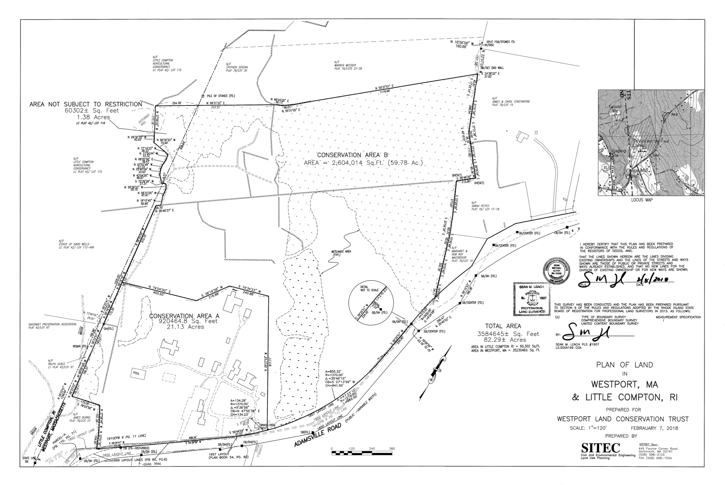

Exhibit B: Town Meeting Vote

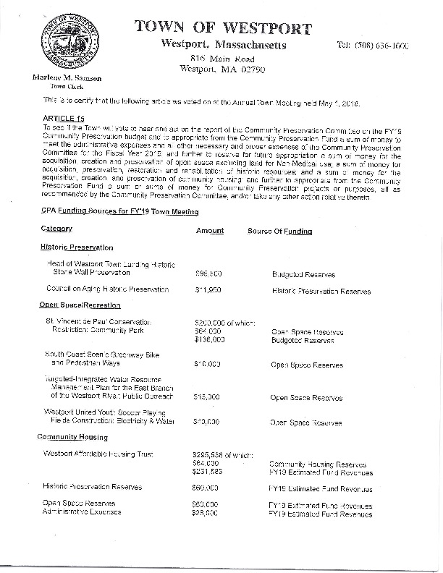
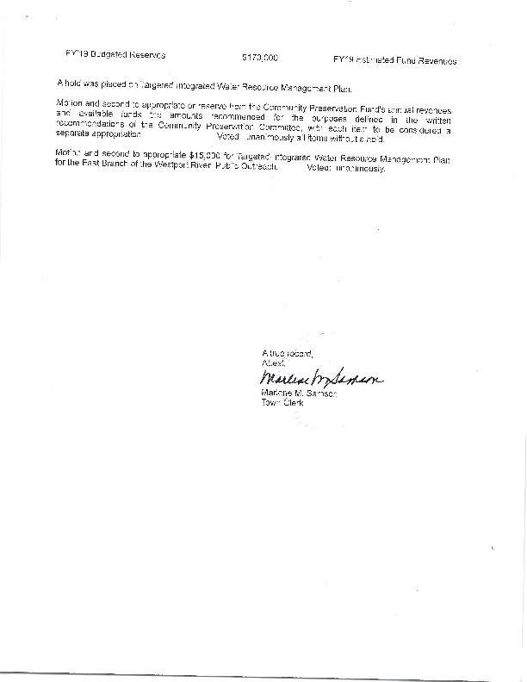

Exhibit C: Sketch Plan of Use Area

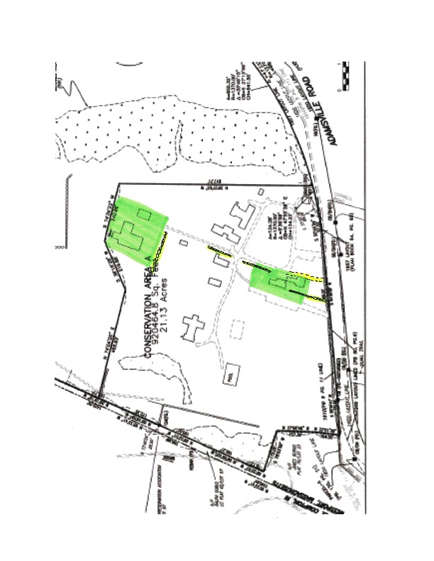
Gymnasium Envelope
Historic House Envelope

